**Table1:** **Demographic characteristics of patients.**

|  | **KNH**, N = 7 | | | **M.P. SHAH**, N = 1 | | **TNH**, N = 8 | | | |
| --- | --- | --- | --- | --- | --- | --- | --- | --- | --- |
| **Characteristic** | **N** | **Candida albicans**, N = 51 | **Candida parapsilosis**, N = 21 | **N** | **Candida parapsilosis**, N = 11 | **N** | **Candida albicans**, N = 21 | **Candida parapsilosis**, N = 51 | **Candida tropicalis**, N = 11 |
| **Patient location** | 7 |  |  | 1 |  | 8 |  |  |  |
| Main ICU |  | 1 / 5 | - |  |  |  | - | 5 / 5 | 1 / 1 |
| Newborn unit |  | 1 / 5 | - |  |  |  |  |  |  |
| Pediatrics renal unit |  | 1 / 5 | - |  |  |  |  |  |  |
| Pediatrics |  | 1 / 5 | 1 / 2 |  |  |  |  |  |  |
| Private wing |  | 1 / 5 | 1 / 2 |  |  |  |  |  |  |
| Adult HDU |  |  |  |  | 1 / 1 |  |  |  |  |
| Medical |  |  |  |  |  |  | 1 / 2 | - | - |
| Surgical |  |  |  |  |  |  | 1 / 2 | - | - |
| **Gender** | 7 |  |  | 1 |  | 8 |  |  |  |
| Female |  | 3 / 5 | - |  | 1 / 1 |  | - | 2 / 5 | - |
| Male |  | 2 / 5 | 2 / 2 |  |  |  | 2 / 2 | 3 / 5 | 1 / 1 |
| **Age categories** | 7 |  |  | 1 |  | 8 |  |  |  |
| Adult |  | 1 / 5 | 1 / 2 |  | 1 / 1 |  | 2 / 2 | 5 / 5 | 1 / 1 |
| Child |  | 2 / 5 | 1 / 2 |  |  |  |  |  |  |
| Infant |  | 2 / 5 | - |  |  |  |  |  |  |
| 1n / N | | | | | | | | | |

**Table 2: Reasons for current admission**

|  | **KNH**, N =7 | | | **M.P. SHAH**, N =1 | | **TNH**, N =8 | | | |
| --- | --- | --- | --- | --- | --- | --- | --- | --- | --- |
| **Characteristic** | **N** | **Candida albicans**, N = 51 | **Candida parapsilosis**, N = 21 | **N** | **Candida parapsilosis**, N = 11 | **N** | **Candida albicans**, N = 21 | **Candida parapsilosis**, N = 51 | **Candida tropicalis**, N = 11 |
| **Sepsis suspected focus of infection** | 4 |  |  | 1 |  | 5 |  |  |  |
| Blood stream infection |  | 2 / 5 | - |  | 1 / 1 |  | - | - | 1 / 1 |
| Pneumonia |  | 1 / 5 | - |  |  |  | - | 2 / 5 | 1 / 1 |
| Complicated abdominal infection |  |  |  |  |  |  | 1 / 2 | - | - |
| Other |  | - | 1 / 2 |  |  |  |  |  |  |
| **Specify other sepsis** | 1 |  |  | - | - | - | - | - | - |
| Tonsillar infection |  | - | 1 / 2 |  |  |  |  |  |  |
| **Respiratory** | - | - | - | - | - | 4 |  |  |  |
| Acute respiratory failure |  |  |  |  |  |  | 1 / 2 | - | - |
| COPD |  |  |  |  |  |  | - | 1 / 5 | - |
| Other |  |  |  |  |  |  | - | 1 / 5 | 1 / 1 |
| **Please specify other respiratory** | - | - | - | - | - | 2 |  |  |  |
| Pulmonary oedema |  |  |  |  |  |  | - | 1 / 5 | - |
| **Central nervous system** | 2 |  |  | - | - | 1 |  |  |  |
| Status epilepticus |  | - | 1 / 2 |  |  |  |  |  |  |
| Malignancy brain tumor |  |  |  |  |  |  | - | - | 1 / 1 |
| Other |  | 1 / 5 | - |  |  |  |  |  |  |
| **Please specify other CNS** | 1 |  |  | - | - | - | - | - | - |
| Traumatic brain injury |  | 1 / 5 | - |  |  |  |  |  |  |
| **Renal** | 1 |  |  | 1 |  | 2 |  |  |  |
| Acute renal failure |  | 1 / 5 | - |  |  |  | 1 / 2 | - | 1 / 1 |
| Chronic kidney disease |  |  |  |  | 1 / 1 |  |  |  |  |
| **GI** | - | - | - | - | - | 1 |  |  |  |
| Cholelithiasis |  |  |  |  |  |  | 1 / 2 | - | - |
| **Stabilization post-surgery** | - | - | - | - | - | 1 |  |  |  |
| Stabilization post-surgery |  |  |  |  |  |  | - | - | 1 / 1 |
| **Neonatal** | 2 |  |  | - | - | - | - | - | - |
| Neonatal sepsis |  | 1 / 5 | - |  |  |  |  |  |  |
| Other |  | 1 / 5 | - |  |  |  |  |  |  |
| **Please specify other neonatal** | 1 |  |  | - | - | - | - | - | - |
| Severe perinatal asphyxia |  | 1 / 5 | - |  |  |  |  |  |  |
| **Miscellaneous** | - | - | - | - | - | 3 |  |  |  |
| Other miscellaneous |  |  |  |  |  |  | - | 2 / 5 | 1 / 1 |
| **Specify other miscellaneous** | - | - | - | - | - | 3 |  |  |  |
| Anemia |  |  |  |  |  |  | - | - | 1 / 1 |
| Pericardial effusion |  |  |  |  |  |  | - | 1 / 5 | - |
| Vasculitis |  |  |  |  |  |  | - | 1 / 5 | - |
| 1n / N | | | | | | | | | |

**Table 3a: Admission Characteristics**

|  | **KNH**, N =7 | | | **M.P. SHAH**, N =1 | | **TNH**, N =8 | | | |
| --- | --- | --- | --- | --- | --- | --- | --- | --- | --- |
| **Characteristic** | **N** | **Candida albicans**, N = 51 | **Candida parapsilosis**, N = 21 | **N** | **Candida parapsilosis**, N = 11 | **N** | **Candida albicans**, N = 21 | **Candida parapsilosis**, N = 51 | **Candida tropicalis**, N = 11 |
| **Patient receive any major surgeries during this admission** | 1 | 1 / 5 | - | - | - | 2 | 1 / 2 | - | 1 / 1 |
| **Number of surgeries** | 1 |  |  | - | - | 2 |  |  |  |
| 1 |  | 1 / 5 | - |  |  |  | 1 / 2 | - | 1 / 1 |
| **Name of surgery** | 1 |  |  | - | - | 2 |  |  |  |
| Abdominal surgery |  | 1 / 5 | - |  |  |  | 1 / 2 | - | - |
| Brain surgery |  |  |  |  |  |  | - | - | 1 / 1 |
| **When was the last surgery** | 1 |  |  | - | - | 2 |  |  |  |
| Last 3 months |  | 1 / 5 | - |  |  |  | 1 / 2 | - | 1 / 1 |
| **Facility of surgery** | 1 |  |  | - | - | 2 |  |  |  |
| Kenyatta National Hospital |  | 1 / 5 | - |  |  |  |  |  |  |
| The Nairobi Hospital |  |  |  |  |  |  | 1 / 2 | - | 1 / 1 |
| **Antifungal drugs received during this admission** | 5 | 4 / 5 | 1 / 2 | 1 | 1 / 1 | 4 | - | 3 / 5 | 1 / 1 |
| **Courses of antifungals** | 5 |  |  | 1 |  | 4 |  |  |  |
| 1 |  | 4 / 5 | 1 / 2 |  | 1 / 1 |  | - | 3 / 5 | 1 / 1 |
| **Antibacterial drugs received during this admission** | 7 | 5 / 5 | 2 / 2 | 1 | 1 / 1 | 8 | 2 / 2 | 5 / 5 | 1 / 1 |
| **Number of courses taken** | 7 |  |  | 1 |  | 8 |  |  |  |
| 1 |  | 1 / 5 | 1 / 2 |  | 1 / 1 |  | 2 / 2 | 1 / 5 | - |
| 2-3 |  | 4 / 5 | 1 / 2 |  |  |  | - | 2 / 5 | - |
| 4-5 |  |  |  |  |  |  | - | 2 / 5 | - |
| More than 5 |  |  |  |  |  |  | - | - | 1 / 1 |
| **Patient have features of sepsis** | 7 | 5 / 5 | 2 / 2 | 1 | 1 / 1 | 8 | 2 / 2 | 5 / 5 | 1 / 1 |
| **Sample collected** | 7 |  |  | 1 |  | 8 |  |  |  |
| Blood culture |  | 5 / 5 | 2 / 2 |  | 1 / 1 |  | 2 / 2 | 5 / 5 | 1 / 1 |
| Tracheal aspirate |  |  |  |  |  |  | - | - | 1 / 1 |
| Urine culture |  |  |  |  |  |  | 2 / 2 | 1 / 5 | - |
| **Specify other samples taken** | - | - | - | - | - | 3 |  |  |  |
| Pus swab/ Wound swab |  |  |  |  |  |  | 2 / 2 | - | - |
| Sputum |  |  |  |  |  |  | - | - | 1 / 1 |
| 1n / N | | | | | | | | | |

**Table 3b: Characteristics of cases reported for patients on invasive procedures.**

|  | **KNH**, N =19 | | | | | **M.P. SHAH**, N =2 | | | **TNH**, N =45 | | | | | | |
| --- | --- | --- | --- | --- | --- | --- | --- | --- | --- | --- | --- | --- | --- | --- | --- |
| **Characteristic** |  | **Candida albicans**, N = 151 | | **Candida parapsilosis**, N = 41 | |  | **Candida parapsilosis**, N = 21 | |  | **Candida albicans**, N = 131 | | **Candida parapsilosis**, N = 221 | | **Candida tropicalis**, N = 101 | |
| **Invasive** | | |  | |  | | |  | | |  | |  | |  |
| Central venous catheter | | | 3 (20%) | | - | | |  | | | 2 (15%) | | 1 (4.5%) | | 1 (10%) |
| Chemoport | | | 1 (6.7%) | | 1 (25%) | | |  | | |  | |  | |  |
| Endotracheal tube | | | 1 (6.7%) | | - | | |  | | | 2 (15%) | | 2 (9.1%) | | 1 (10%) |
| Gastrointestinal tube (PEG-J) | | | - | | 1 (25%) | | |  | | | - | | 1 (4.5%) | | 1 (10%) |
| Mechanical ventilation | | | 2 (13%) | | - | | |  | | | 2 (15%) | | 3 (14%) | | 1 (10%) |
| Nasogastricnasoduodenal tube | | | 1 (6.7%) | | 1 (25%) | | |  | | | 1 (7.7%) | | 4 (18%) | | 1 (10%) |
| Other non-peripheral access | | | 1 (6.7%) | | - | | |  | | |  | |  | |  |
| PEG tube changes | | | 1 (6.7%) | | - | | |  | | |  | |  | |  |
| Peripheral venous catheter | | | 2 (13%) | | 1 (25%) | | | 1 (50%) | | | 1 (7.7%) | | 2 (9.1%) | | - |
| Surgical drain | | | 1 (6.7%) | | - | | |  | | | - | | - | | 1 (10%) |
| Tracheostomy | | | 1 (6.7%) | | - | | |  | | | - | | 2 (9.1%) | | 1 (10%) |
| Surgical ostomy without tube colostomy | | |  | |  | | |  | | | 1 (7.7%) | | - | | - |
| Total parenteral nutrition | | |  | |  | | |  | | | 1 (7.7%) | | - | | - |
| Urinary catheter | | |  | |  | | |  | | | 1 (7.7%) | | 4 (18%) | | 1 (10%) |
| Wound vac | | |  | |  | | |  | | | 2 (15%) | | - | | 1 (10%) |
| Dialysis | | | 1 (6.7%) | | - | | | 1 (50%) | | | - | | 3 (14%) | | 1 (10%) |
| **Type of dialysis** | | |  | |  | | |  | | |  | |  | |  |
| Peritoneal | | | 1 (100%) | | - | | |  | | |  | |  | |  |
| Hemodialysis | | |  | |  | | | 1 (100%) | | | - | | 3 (100%) | | 1 (100%) |
| **If hemodialysis type of access** | | | - | | - | | |  | | |  | |  | |  |
| hemodialysis central line | | |  | |  | | | 1 (100%) | | | - | | 2 (67%) | | 1 (100%) |
| av fistulagraft | | |  | |  | | |  | | | - | | 1 (33%) | | - |

**Table 4: Underlying Conditions**

|  | **KNH**, N =7 | | | **M.P. SHAH**, N =1 | | **TNH**, N =8 | | | |
| --- | --- | --- | --- | --- | --- | --- | --- | --- | --- |
| **Characteristic** | **N** | **Candida albicans**, N = 51 | **Candida parapsilosis**, N = 21 | **N** | **Candida parapsilosis**, N = 11 | **N** | **Candida albicans**, N = 21 | **Candida parapsilosis**, N = 51 | **Candida tropicalis**, N = 11 |
| **Underlying conditions at time of admission** | 7 |  |  | 1 |  | 8 |  |  |  |
| None |  | 3 / 5 | 1 / 2 |  |  |  | - | - | 1 / 1 |
| Yes |  | 2 / 5 | 1 / 2 |  | 1 / 1 |  | 2 / 2 | 5 / 5 | - |
| **Underlying condition** | - | - | - | 1 |  | 3 |  |  |  |
| Cardiovascular disease |  |  |  |  | 1 / 1 |  | 2 / 2 | 1 / 5 | - |
| Diabetes mellitus |  | 1 / 5 | - |  |  |  | - | 2 / 5 | - |
| Chronic kidney disease |  |  |  |  | 1 / 1 |  |  |  |  |
| HIV infection |  | 1 / 5 | - |  |  |  | - | 1 / 5 | - |
| Liver disease |  | 1 / 5 | - |  |  |  |  |  |  |
| Malignancy |  | 1 / 5 | - |  |  |  | - | 1 / 5 | - |
| Neurologic condition |  | 1 / 5 | 1 / 2 |  |  |  |  |  |  |
| (**pediatric neonatal condition**) Malnutrition |  | 1 / 5 | - |  |  |  |  |  |  |
| 1n / N | | | | | | | | | |

**Table 5: Patient characteristics related to MDRO and Antifungal susceptibility testing.**

|  | **KNH**, N =7 | | | **M.P. SHAH**, N =1 | | **TNH**, N =8 | | | |
| --- | --- | --- | --- | --- | --- | --- | --- | --- | --- |
| **Characteristic** | **N** | **Candida albicans**, N = 51 | **Candida parapsilosis**, N = 21 | **N** | **Candida parapsilosis**, N = 11 | **N** | **Candida albicans**, N = 21 | **Candida parapsilosis**, N = 51 | **Candida tropicalis**, N = 11 |
| **Had an MDRO in the last 90 days including this admission** | - | - | - | - | - | - | - | - | - |
| **Antifungal Susceptibility test** |  |  |  |  |  |  |  |  |  |
| **Fluconazole** | 7 |  |  | 1 |  | 8 |  |  |  |
| Susceptible |  | 5 / 5 | 2 / 2 |  | 1 / 1 |  | 1 / 2 | 1 / 5 | 1 / 1 |
| Resistant |  |  |  |  |  |  | 1 / 2 | 4 / 5 | - |
| **Caspofungin** | 7 |  |  | 1 |  | 8 |  |  |  |
| Susceptible |  | 5 / 5 | 2 / 2 |  | 1 / 1 |  | 2 / 2 | 5 / 5 | 1 / 1 |
| **Voriconazole** | 7 |  |  | 1 |  | 8 |  |  |  |
| Susceptible |  | 5 / 5 | 2 / 2 |  | 1 / 1 |  | 2 / 2 | 5 / 5 | 1 / 1 |
| **Amphotericin b** | 7 |  |  | 1 |  | 8 |  |  |  |
| Susceptible |  | 5 / 5 | 2 / 2 |  | 1 / 1 |  | 2 / 2 | 5 / 5 | 1 / 1 |
| **Micafungin** | 7 |  |  | 1 |  | 8 |  |  |  |
| Susceptible |  | 5 / 5 | 2 / 2 |  | 1 / 1 |  | 2 / 2 | 5 / 5 | 1 / 1 |
| **Patient transferred or referred from another hospital or admitted to another hospital within the last 3 months** | 7 | 4 / 5 | 1 / 2 | 1 | 1 / 1 | 8 | 0 / 2 | 1 / 5 | - |
| **Patient outcome** | 7 |  |  | 1 |  | 8 |  |  |  |
| Deceased |  | 4 / 5 | - |  |  |  | - | 1 / 5 | 1 / 1 |
| Discharged |  | 1 / 5 | 2 / 2 |  | 1 / 1 |  | 1 / 2 | 2 / 5 | - |
| Referral |  |  |  |  |  |  | 1 / 2 | - | - |
| Transferred to another unit |  |  |  |  |  |  | - | 2 / 5 | - |
| 1n / N | | | | | | | | | |

**Table 6a: Characteristics of patient-reported antibiotic cases.**

|  | **KNH**, N =19 | | | **M.P. SHAH**, N =1 | | **TNH**, N =27 | | | |
| --- | --- | --- | --- | --- | --- | --- | --- | --- | --- |
| **Characteristic** |  | **Candida albicans**, N = 131 | **Candida parapsilosis**, N = 61 |  | **Candida parapsilosis**, N = 11 |  | **Candida albicans**, N = 71 | **Candida parapsilosis**, N = 191 | **Candida tropicalis**, N = 11 |
| |  |  |  |  |  |  |  | | --- | --- | --- | --- | --- | --- | --- | | **Drug** |  |  |  |  |  |  | | Aminoglycosides | 2 (15%) | 1 (17%) |  | 1 (14%) | 1 (5.3%) | - | | Carbapenem | 3 (23%) | 1 (17%) |  | 2 (29%) | 3 (16%) | 1 (100%) | | Cephalosporins | 1 (7.7%) | 2 (33%) |  | - | 5 (26%) | - | | Glycopeptides | 1 (7.7%) | - | 1 (100%) | - | 1 (5.3%) | - | | Macrolides | - | 1 (17%) |  | 1 (14%) | 1 (5.3%) | - | | Nitroimidazole | 1 (7.7%) | - |  | - | 1 (5.3%) | - | | Penicillin | 2 (15%) | 1 (17%) |  | - | 1 (5.3%) | - | | Penicillin with enzyme inhibitor | 2 (15%) | - |  | 2 (29%) | 4 (21%) | - | | Quinolones | 1 (7.7%) | - |  | 1 (14%) | - | - | | Lincosamide |  |  |  | - | 2 (11%) | - | | **Route** |  |  |  |  |  |  | | Intravenous | 13 (100%) | 5 (83%) | 1 (100%) | 6 (86%) | 18 (95%) | 1 (100%) | | Oral | - | 1 (17%) |  | 1 (14%) | 1 (5.3%) | - | | | | | | | | | | |
|  | | | | | | | | | |

**Figure 1: Antibiotic usage by age demographics**

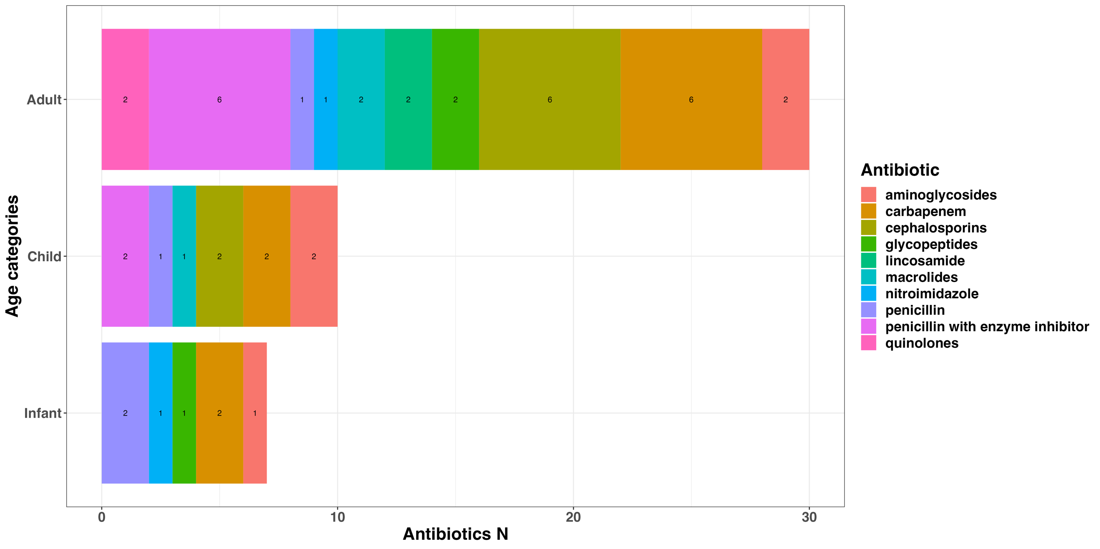

**Figure 2: Antibiotic usage by patient location**

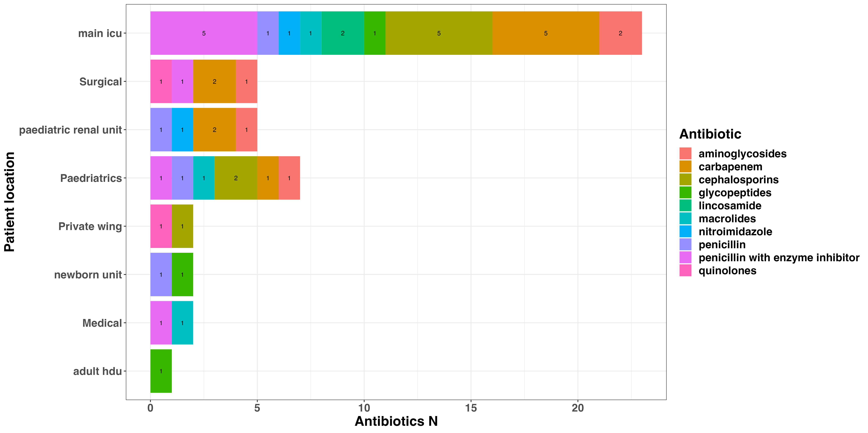

**Table 6b: Characteristics of patient-reported antifungal cases.**

|  | **KNH**, N =5 | | | **M.P. SHAH**, N =1 | | **TNH**, N =4 | | |
| --- | --- | --- | --- | --- | --- | --- | --- | --- |
| **Characteristic** |  | **Candida albicans**, N = 41 | **Candida parapsilosis**, N = 11 |  | **Candida parapsilosis**, N = 11 |  | **Candida parapsilosis**, N = 31 | **Candida tropicalis**, N = 11 |

|  |  |  |  |  |  |
| --- | --- | --- | --- | --- | --- |
| **Indication if due to isolation of another candida species list species and specimen site** |  |  |  |  |  |
| Candida albicans | 2 (50%) | - |  |  |  |
| Candidemia | 1 (25%) | 1 (100%) |  |  |  |
| Prophylaxis | 1 (25%) | - |  | 2 (67%) | 1 (100%) |
| Candida parapsilosis |  |  | 1 (100%) | 1 (33%) | - |
| **Drug** |  |  |  |  |  |
| Azoles | 3 (75%) | 1 (100%) |  | - | 1 (100%) |
| Polyene | 1 (25%) | - |  |  |  |
| Echinocandin |  |  | 1 (100%) | 3 (100%) | - |
| **Route** |  |  |  |  |  |
| Intravenous | 1 (25%) | - | 1 (100%) | 3 (100%) | 1 (100%) |
| Oral | 2 (50%) | 1 (100%) |  |  |  |
| Topical | 1 (25%) | - |  |  |  |

|  |
| --- |
|  |

**Figure 3: Antifungals usage by age demographics**

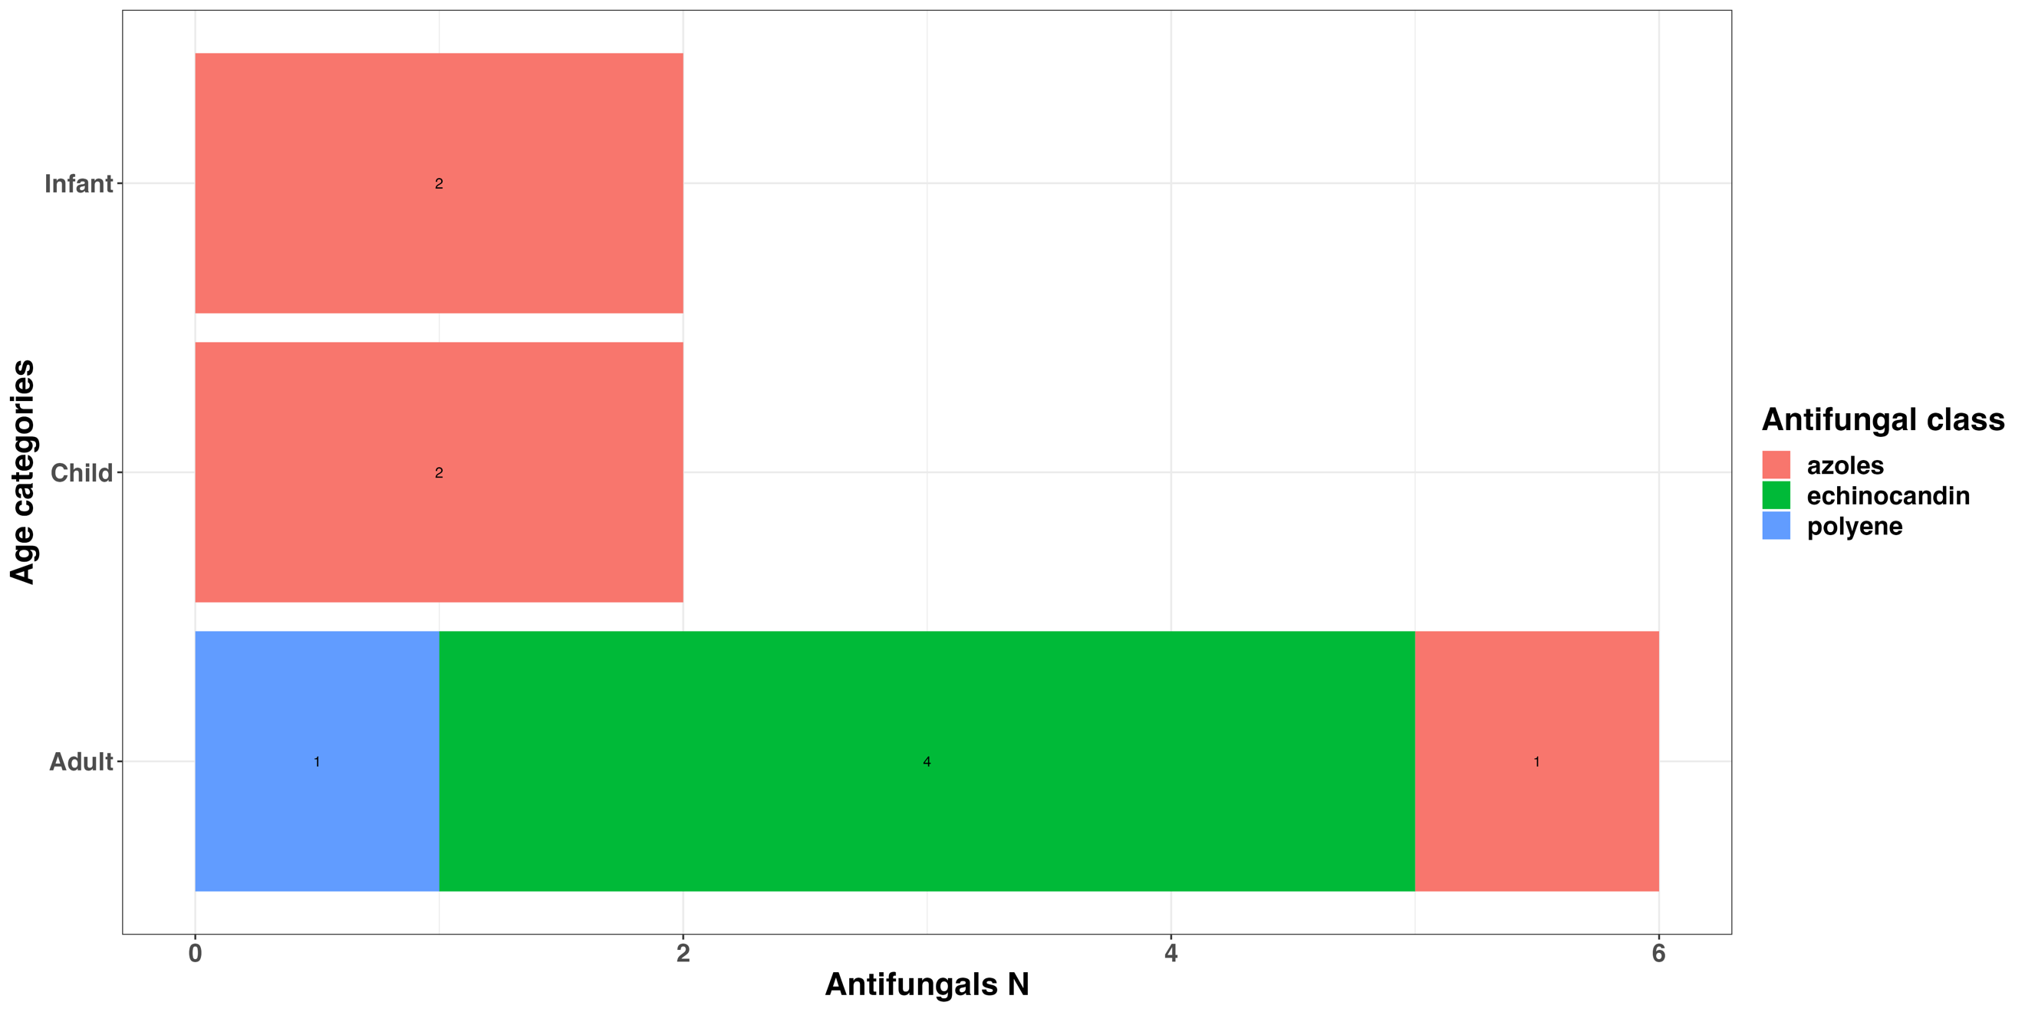

**Figure 4: Antifungal usage by patient location**

